ContactManagement_Verify Contact notes _Instance44_12-Jul-2018_03-12-14_AM_Validatingcontactentitynavigation.png

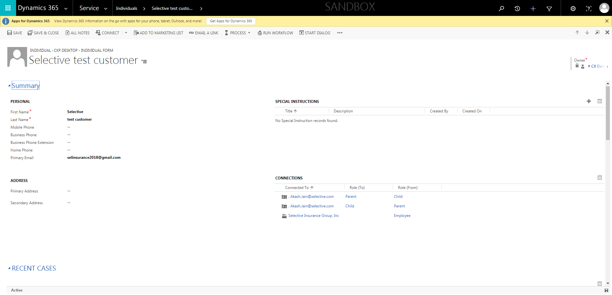

ContactManagement_Verify Contact notes _Instance44_12-Jul-2018_03-10-48_AM_EnterTextAction.png

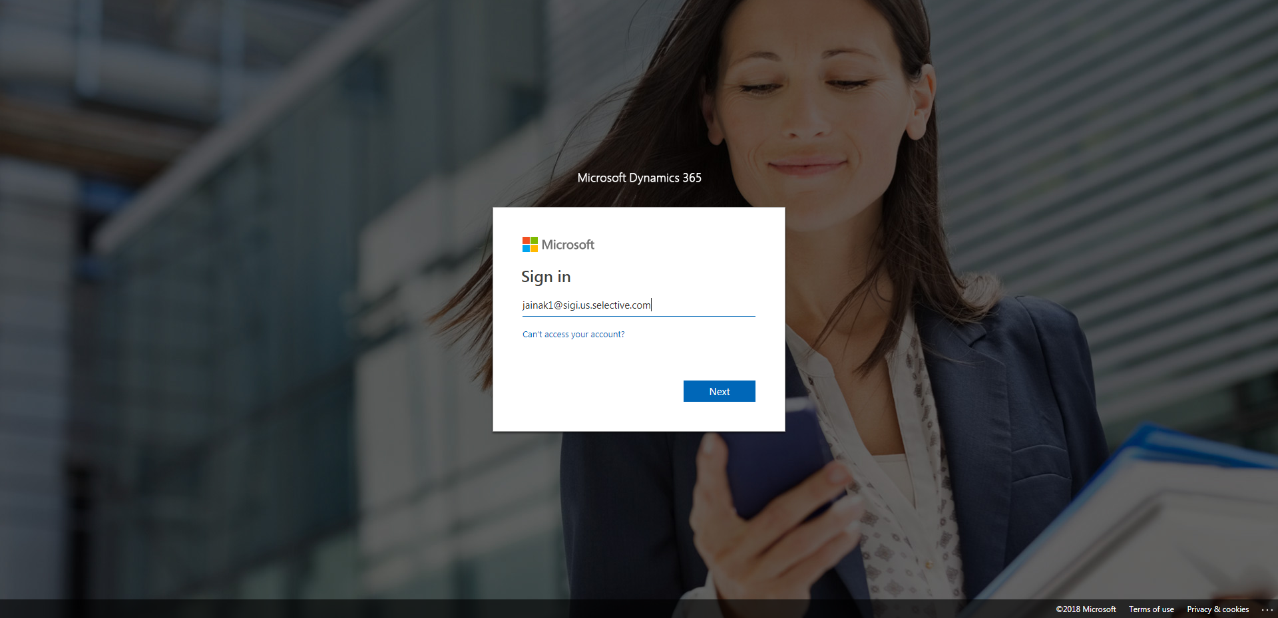

ContactManagement_Verify Contact notes _Instance44_12-Jul-2018_03-11-03_AM_SingleSignOn.png

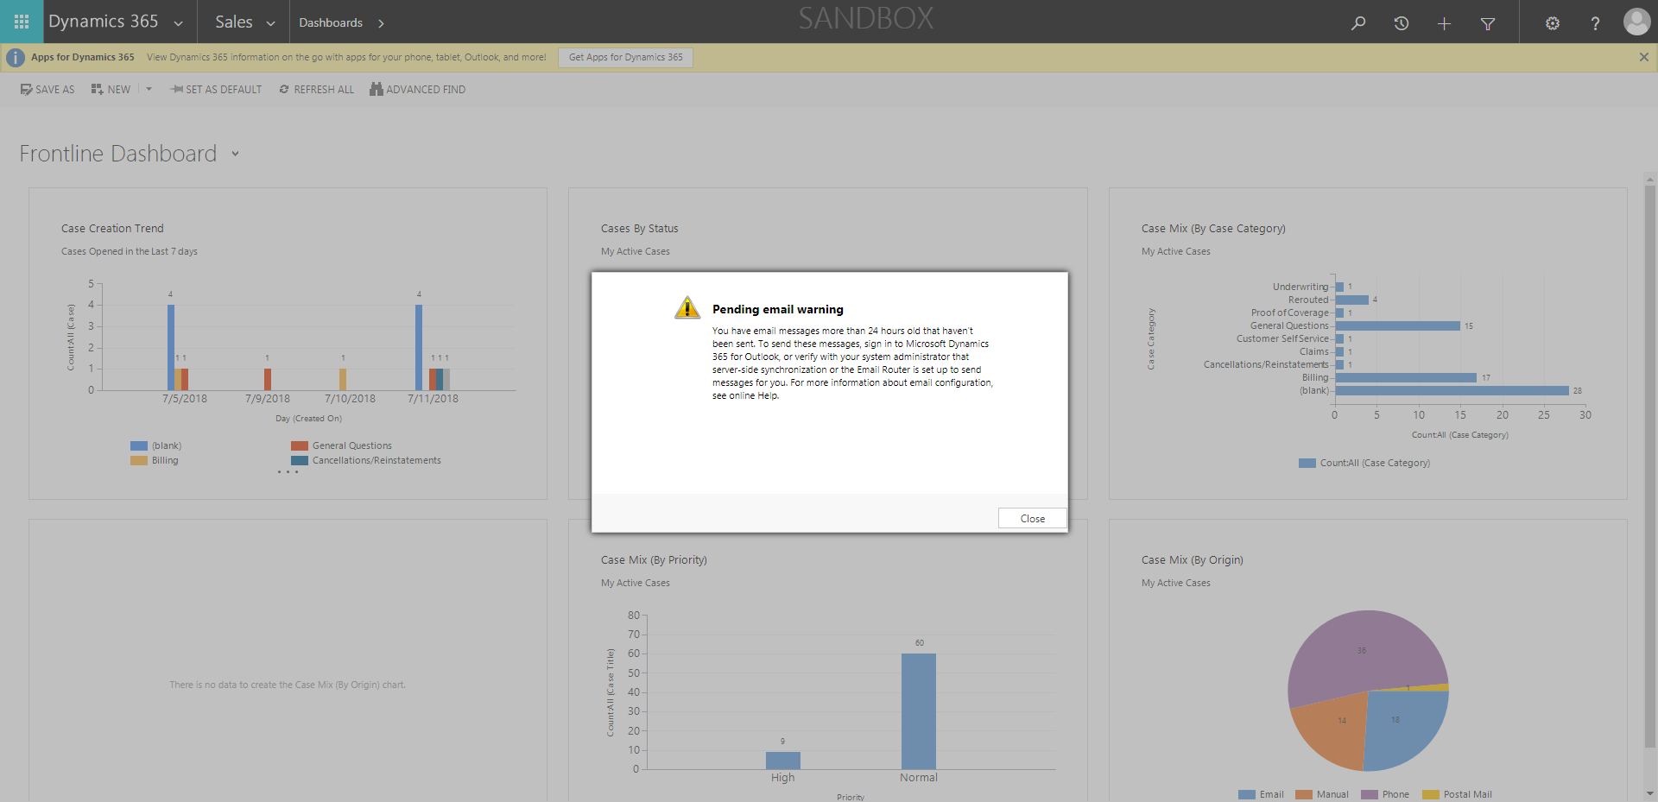

ContactManagement_Verify Contact notes _Instance44_12-Jul-2018_03-10-46_AM_MouseClickActiononStaleElement.png



ContactManagement_Verify Contact notes _Instance44_12-Jul-2018_03-11-07_AM_SingleSignOn.png

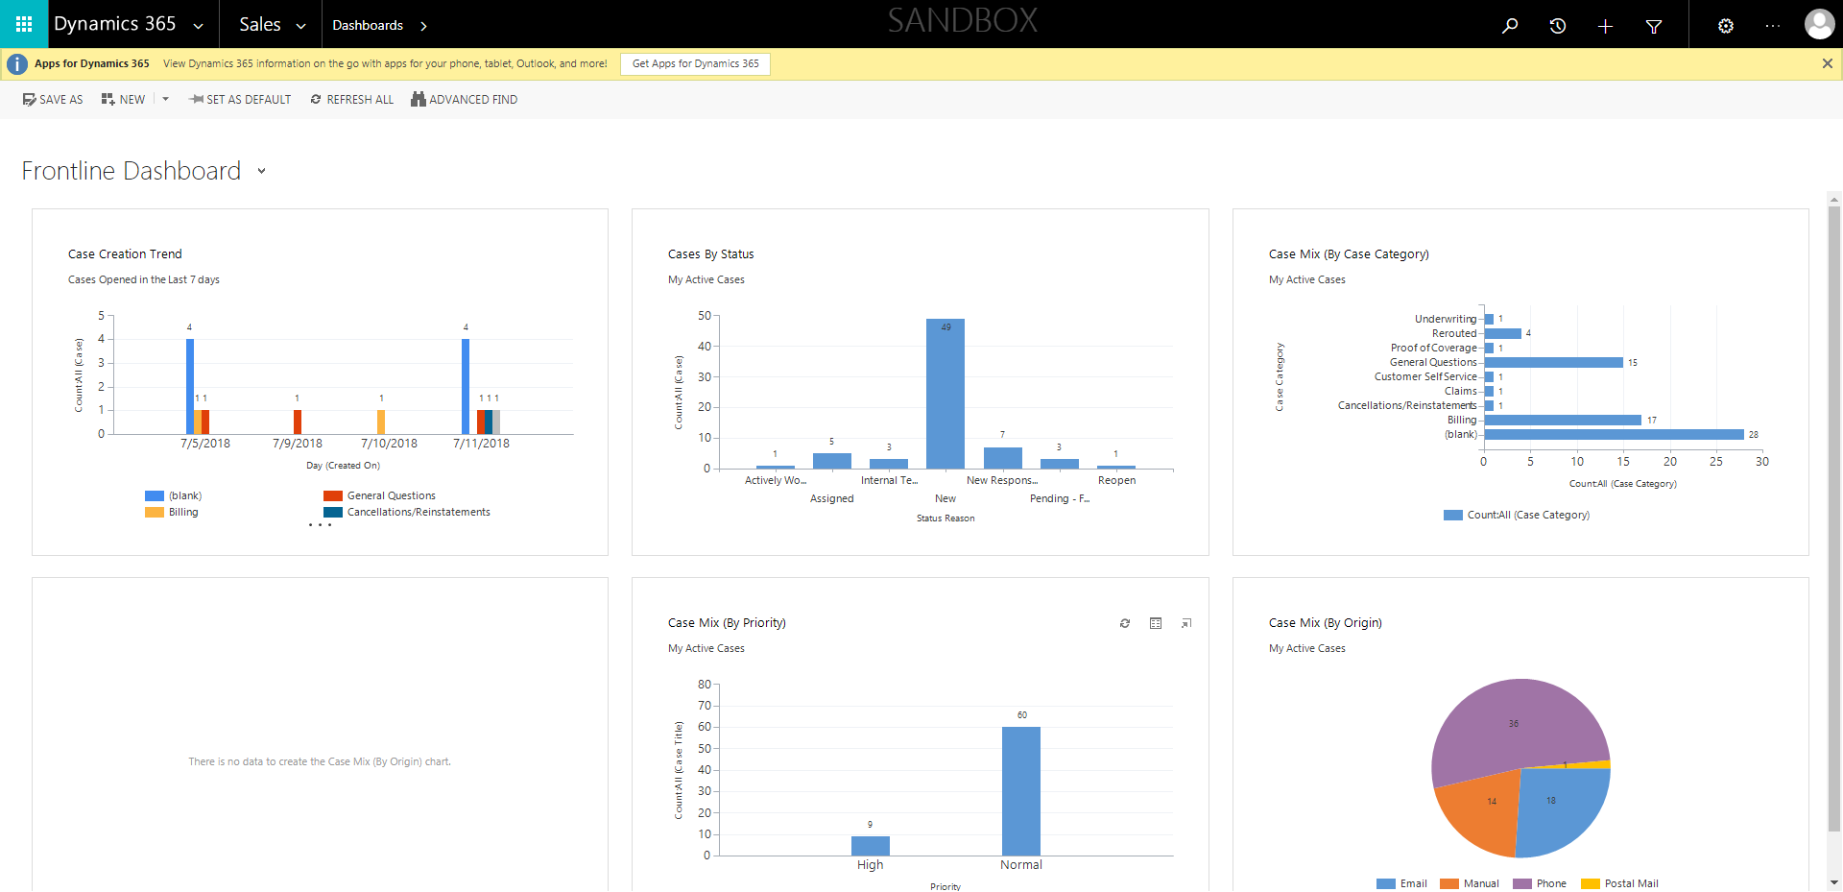

ContactManagement_Verify Contact notes _Instance44_12-Jul-2018_03-12-28_AM_VerifyingAllNotesofanindividual.png

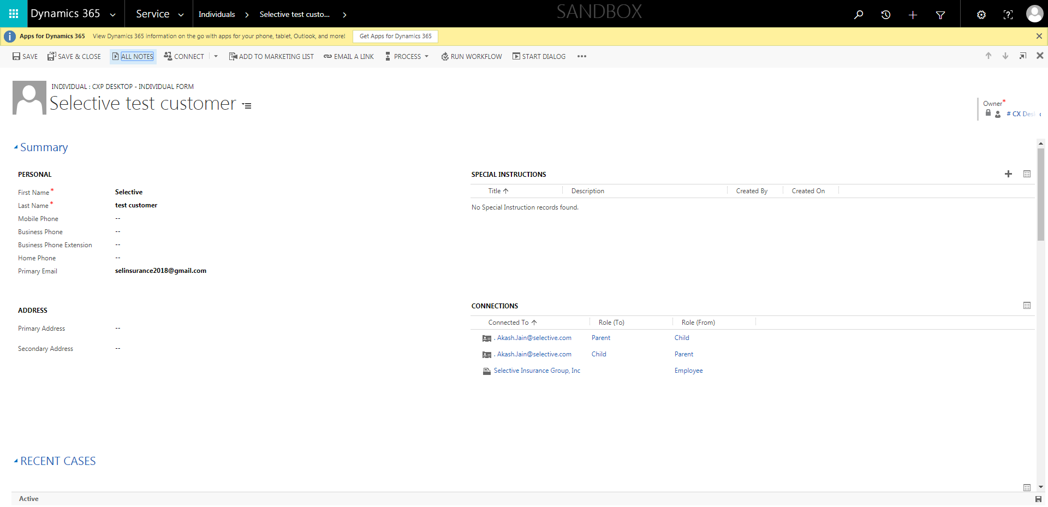

ContactManagement_Verify Contact notes _Instance44_12-Jul-2018_03-10-49_AM_MouseClickActiononStaleElement.png

